How have you gained experience with (multiple answers possible)…
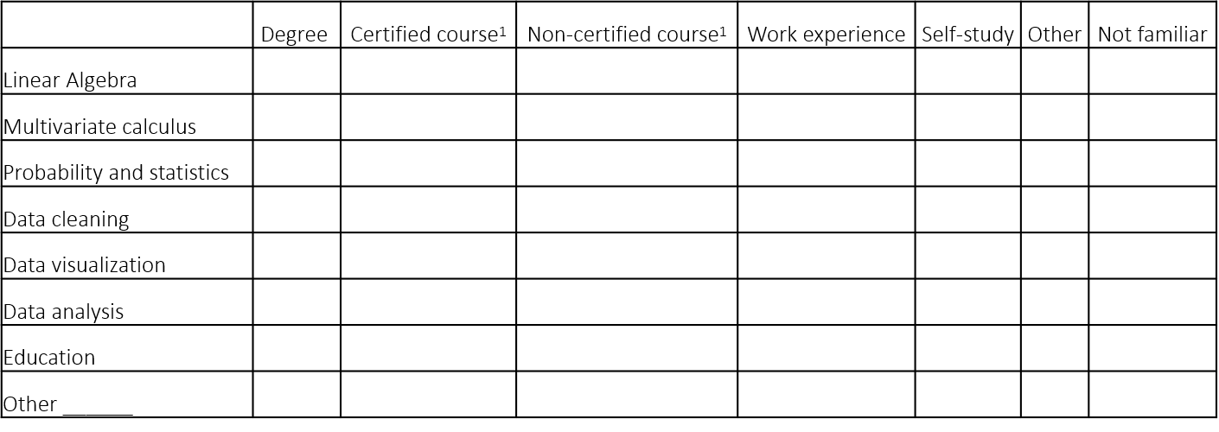
¹Courses that are not part of your degree. Think of (certified) courses from Coursera or courses from a Summer School.

If your answer has been other than” degree” or “certified course”, please elaborate on your answer (1000 characters or less).

