Skills Matrix for Education Data Science
How have you gained experience with (multiple answers possible)…
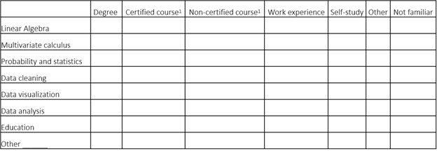Courses that are not part of your degree. Think of (certified) courses from Coursera or courses from a Summer School.
If your answer has been other than” degree” or “certified course”, please elaborate on your answer (1000 characters or less).

