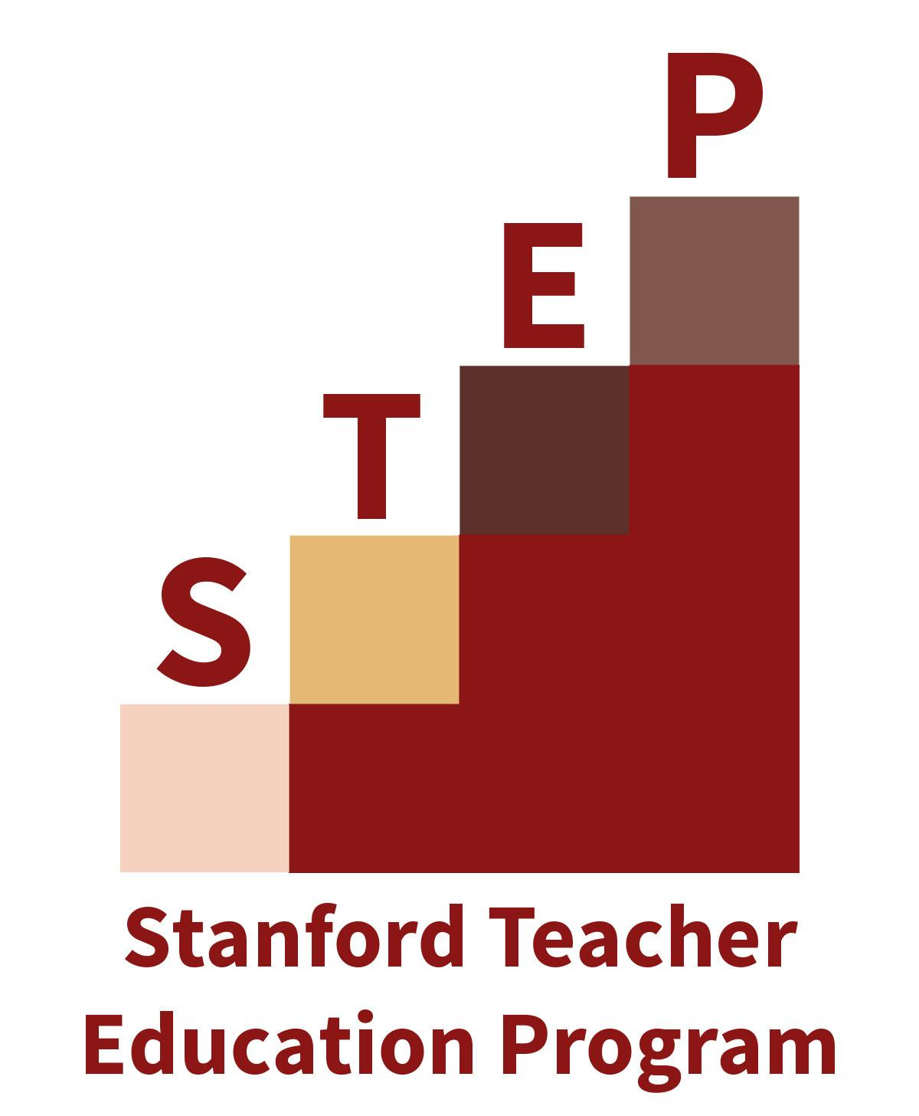

Release Form

In STEP, we are continually working to improve and promote our practice as teacher educators. Just as we ask you to reflect upon and assess your practice, we are regularly examining what we can do to improve our teaching and your learning. Additionally, sharing our collective understandings about teaching and learning via our website, other online platforms, and at conferences is important to promote productive educational practices with others. To that end, we ask below for permission to collect samples of your work, along with photos and videos, to help support our ongoing learning, improvement, and sharing of quality teaching and teacher education.

I, , give permission for samples of my work in STEP, as well as photographic and/or videotaped images made of me while participating in clinical placement, university courses, meetings, or events, in any manner it deems proper, including, but not limited to research and educational purposes, promotional activities, in print and electronic publications, on its website, in social media, or in multimedia.

I relinquish all rights, title, and interest I may have in the information collected, finished pictures, negatives, slides, digital images and/or copies of any of these for this purpose. I waive the right of prior approval and hereby release STEP from any and all claims for damages of any kind based on this use of said material. I am of legal age and freely sign this release, which I have read and understand.

Signature:

Printed Name: Date:

